Nathan O’Dell
04/19/26
CS 255 System Design Document Template

UML Diagrams

UML Use Case Diagram
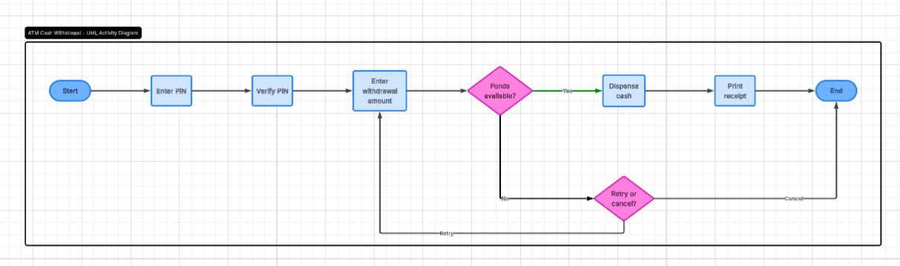

UML Activity Diagrams
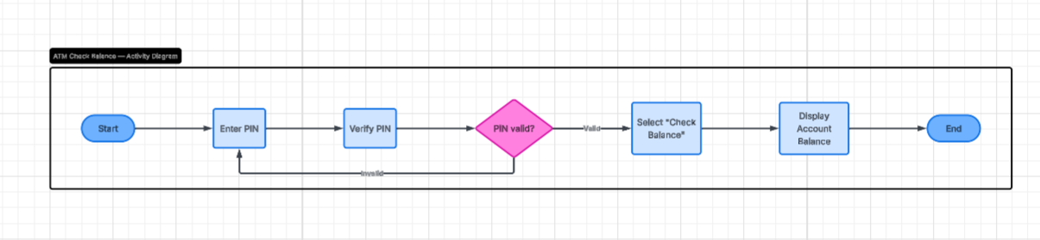

UML Sequence Diagram
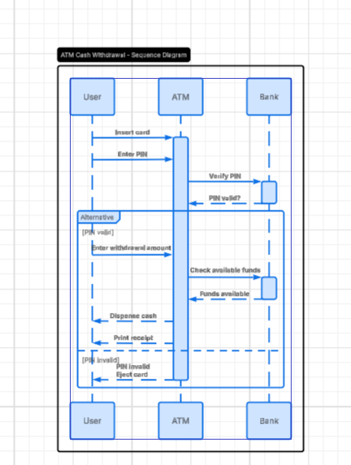

UML Class Diagram
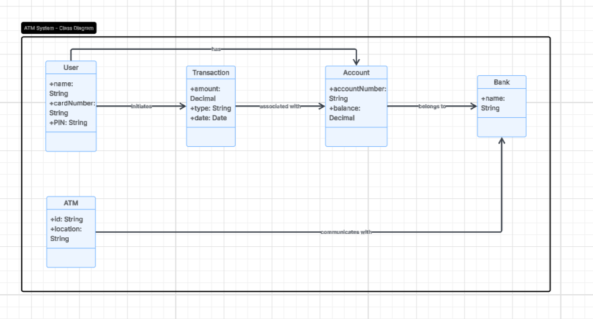

Technical Requirements
The system requires a device with internet access and a secure connection to the bank’s network. It runs on a server that processes transactions and stores account data. The system uses software to handle user input, verify PINs, check balances, and complete transactions. A database is required to store user and account information. Security measures such as authentication and encryption are necessary to protect sensitive data. The system must also be reliable and able to handle multiple users without errors.

